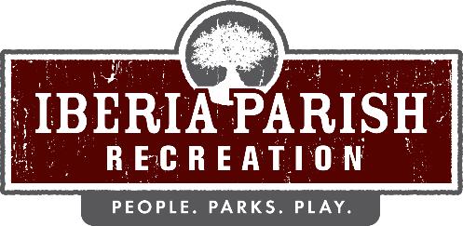

Agenda for the rescheduled regular board meeting of the IBERIA PARISH RECREATION AND PLAYGROUND COMMISSION to be held on THURSDAY, October 15, 2020 at 6:15 PM in the meeting room at the Willow Wood Administrative Building located in Willow Wood Park, 113 Willow Wood Drive, New Iberia, LA.

- Opening Prayer.

- Call to order.

- Roll call.

- Consider a motion to approve the minutes of the regular board meeting held on September 17, 2020 meeting as published and take appropriate action.

- Receive a report from the Director on storm damage and take appropriate action.

- Review and discuss End of Year Budget Adjustments and take appropriate action.

- Announcements.
- Sales Tax Recap for the month of September 2020
- Recap of 2020 Sales Tax Collections

- Correspondence

- Adjournment.

NEXT SCHEDULED BOARD MEETING - THURSDAY, November 12, 2020 @ 6:15PM

